C o m p l e t i n g D P A ( D a i l y P h y s i c a l A c t i v it y )

All students must complete 150 minutes per week of physical activity for grades 9, 10, 11 and 12 and report out on it. That is, each September you will start recording you DPA with a blank template for your grade level.

- Log into any computer at school, home, work to: gleneagle.org
- select “Programs & Services”
- then “Grad Transitions
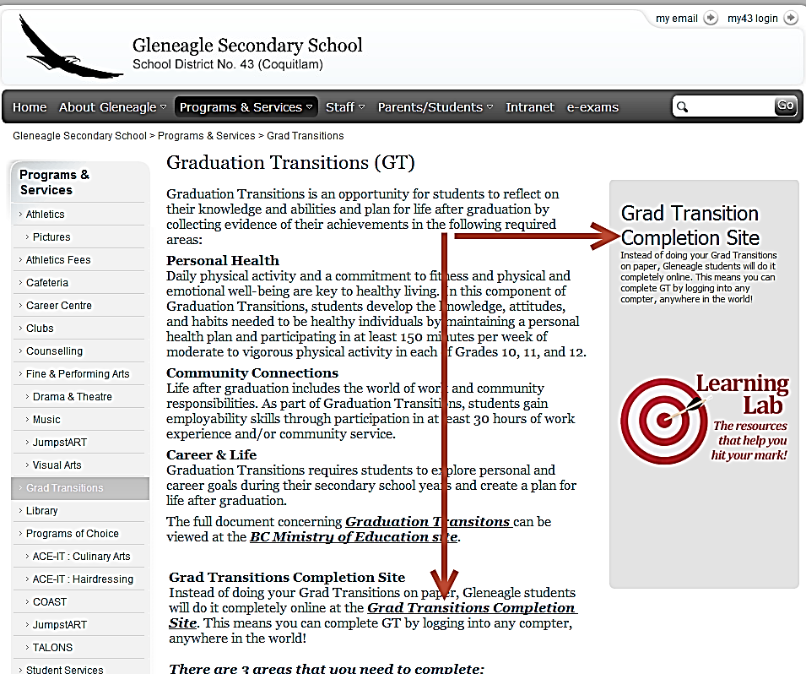

Click on the “Grad Transition Completion” link ........... sign in with your school username and password and you’ll see the new GT website. Follow the instructions.

OR

- Go to gleneagle.org . Click on Intranet and then “gt-dpa”. Log in with your school username and password.
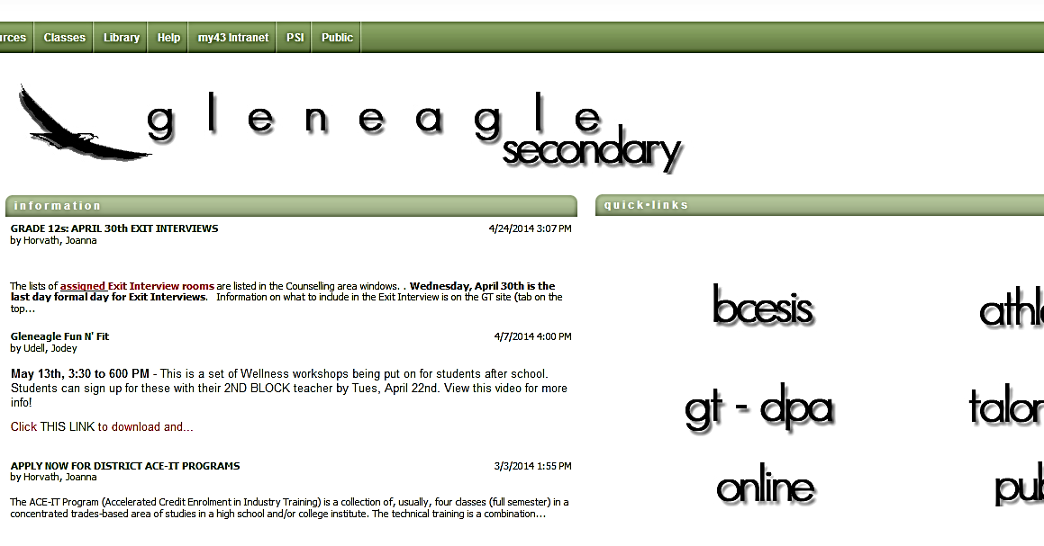
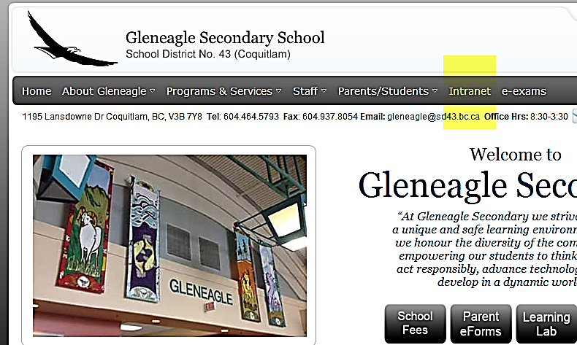

The Graduation Transitions site is where all grades will complete DPA every year, and grade 12s will complete the rest of the GT assignments.

FOLLOW THE INSTRUCTIONS: Step 1 and 2 are very important. Only create ONE folder for yourself (only follow Step 1 instructions the first time you use the site)
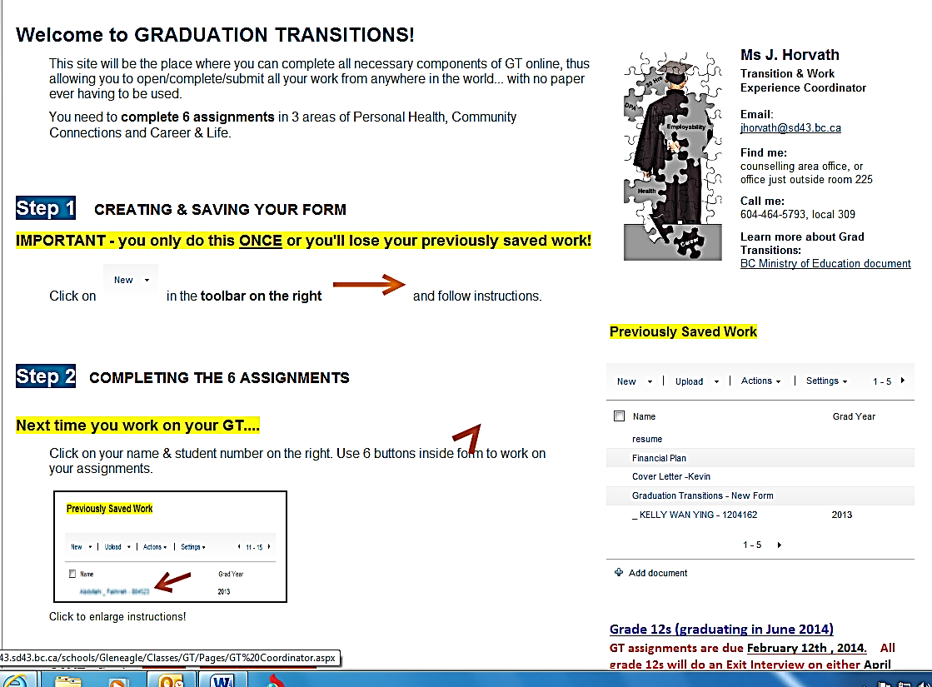

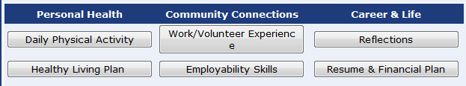

READ THE INSTRUCTIONS: there is specific information you need to include. Follow the instructions at the top of the DPA page

SAVE OFTEN! When you start working on the GT site (each time,) test your connection by saving early on. Copy and save your work in Word.

Email Ms. Horvath (jhorvath@sd43.bc.ca) if you have any questions

